# INTRODUCTION

## Overview

The rise of the Internet has fueled the question across many industries of whether it is a disruptive technology or just another distribution channel. With the rise of Internet banking, the local, regional and global banking industries now face this question, too. The Internet does seem to have some characteristics of a disruptive technology in the banking industry; it has the ability to create major new growth in the industry penetrate, by allowing less-skilled and less affluent people to do things done only by expensive specialists in centralized, inconvenient locations, and it offers consumers products that are cheaper, better, and more convenient than ever before.î2 However, other people see the Internet as just another sustaining technology in banking, providing a new, more convenient distribution channel, like ATM did when first introduced.

The financial institution (Bank) is one of such organizations. Banking constitutes one of the most prominent life wire for Socio-Economic grow and development in any given nation, it supports and assists in the supply of long and short term loan, accepts both current sowing and fixed deposits, both foreign transactions, advice and facilitates transactions between client, workers, agents, firm, buyers and seller by providing payment services, not excluding the issue of undertaking risk on behalf of their clients, only to mention but a few. The internet having found its application and acceptance in the banking procession has particularly put the banking industry on an accelerating pace of development.

Internet banking is thus a remote delivery channel for banking services. These services can be as simple as opening a deposit account or transferring funds, but can also include more complex transactions like electronic bill presentments and payments, and the sale of financial products, like insurance and brokerage.

The technological highway (the internet) has become an enabler for Banks in achieving high level productivity and in handling volumes of transaction which would have been impossible without the use of on-line banking (E-commerce). The technology facilitates linkages with clients both through the provision of information and quality service delivery, as well as in reducing barriers to entry into payment systems retail banking. Internet banking allows clients to engage in informal transaction relationship which would have taken long distance travels or movement of documents with the attendant risk of loss.

## 1.2 Objective

* To improve in the speed, effectiveness, efficiency and convenience in business transaction.
* To reduce the manual workload and give information instantly. The Application will maintain the list of A/C and customer record and Transaction record.
* To be user friendly so that even a beginner can operate the package and thus maintain the status of A/C, do the transaction and maintain balance status easily.
* To design an interface that could be used to input transactions details for customer, and the bank staff information, able to store them in the database for further use and investigations of any bank transactions.
* To allow only authorized user (Bank Employee) to access various functions available in the system.

# PROBLEM ANALYSES

## 2.1 Problem Definition

In banking industries today, queuing has become the order of the day, customer’s line up for hours waiting to transfer money. This creates a lot of problem to both customers as they waste their useful time in the banking hall. The management also wastes their time as they run around to find solution to those problems. Also it is observed that customers cannot transfer money during bank off time.

The purpose of this project is to develop an on-line banking system that provides customers with the facility to check their accounts and do transactions on-line. The system will provide all the banks facilities to its customers when their authentications [user id and password] matches, including viewing account information, performing fund transfers, giving the customer an option of changing address, password retrieval, performing transactions, viewing transactions and locate bank branches. The system allows and should allow customers to view their personnel accounts and to pay bills online from their account. The system should assign a unique transaction number to every transaction that a user makes.

The Administrator will administer both normal bank account. The administrator have the ability to perform various operations like creating a normal bank account for the customer and performing functions like transfers, withdrawals and deposits when the customers want teller transactions. The administrator also has the privilege to close the customer’s account on the request of the bank customer. The customer should be able to access his/her account from anywhere just by inputting the correct user-id and password.

## 2.2 Approach

In the proposed system we are concentrating the problems whatever a client faced with existing manual system. By introducing online fund transaction module, the client provides faster services to the customer. The transaction service is available at no delay With the implementation of online transaction capability, it maintain a direct relationship with the end users via the web and are able to provide a personal characterization to the interface, by real time fund being transferred.

The system can provide information related to the different types of accounts that are existed within the bank. The system can provide the bank administration with information on the number of customers who are existence in the system. The system at any point of time can provide the information related to executed transactions by the customer.

An enhanced atomized system is developed to maintain customer transaction.

Features should include

• Creation of new banking customer

• Customer type – Current Account, Savings Account, Fixed Account

• Customer Creation Form / Account opening form.

• Existing customer Access Form

• Each customer login identified by Account No and User Id.

• Banking Main menu option like: Transaction – Debit, Credit, and Transfer.

• Customer details. Freeze/Unfreeze Account. Back. Quit.

• Transaction Report.

## 2.3 Future scope of the project:

This project was developed to fulfill user requirement; however there are lots of scope to improve the performance of the Banking System in the area of user interface, database performance, and query processing time. So there are many things for future enhancement of this project. The future enhancements that are possible in the project are as follows.

* Interest calculation system is not implemented yet. It can be enhanced later.
* Linking and integration of any legacy system for accounting.
* Integration with other bank and government agencies through Web Services
* Connection to third-party OLAP applications
* Electronic Data Interchange (EDI) system for ATM machine
* Web Interface for net banking.
* In the area of data security and system security

# ARCHITECTURE

## 3.1 System Architecture

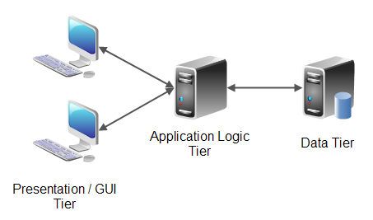

Fig:3.1

The 3-tiered architecture shown above has the following major components:

* Client: There will be two clients for the application. One will be a web-based user-friendly client called bank customers. The other will be for administration purposes.
* Application Server: It takes care of the server script, takes care of JDBC-ODBC driver, and checks for the ODBC connectivity for mapping to the database in order to fulfill client and administrator’s request.
* Database: Database Servers will stores customer’s and bank data.

## 3.2 Programming Language Used

* Programming language used are HTML, JAVA script, J2EE.
* Tools Used are Eclipse, Maven.
* Database Used MySQL

## 3.3 Definition of Terms

* Analysis: Breaking a problem into successively manageable parts for individual study.
* Data flow: Movement of data in a system from a point of origin to specific destination indicated by a line and arrow
* Design: Process of developing the technical and operational specification of a candidate system for implements.
* Implementation: In system development-phase that focuses on user training, site preparation and file conversion for installing a candidate system
* Operation System: In database – machine based software that facilitates the availability of information or reports through the DBMS.
* Password: Identity authenticators a key that allow access to a program system a procedure.
* System: A regular or orderly arrangements of components or parts in a connected and interrelated series or whole a group of components necessary to some operation.
* System Design: Detailed concentration on the technical and other specification that will make the new system operational.
* System Testing: Testing the whole system by the user after major programs and subsystem has been tested.
* Unit testing: Testing changes made in an existing or new programs.

# DESIGN

## 4.1 System Flow

The data flow diagram depicts the flow of the information within the system. The system and its user act as link with all the information following into them. Customer/admin act the source as all the request are generated by him. The record is held in the storage spaces depict by partially open rectangle. Arrows within the flow diagram is quit important as its records in a pictorial form all the information flow within the system. With the help of flow diagram we can identify the current information structure of the system. The structure of the system can thus be analyzed and it helps in making improvement within the current system.

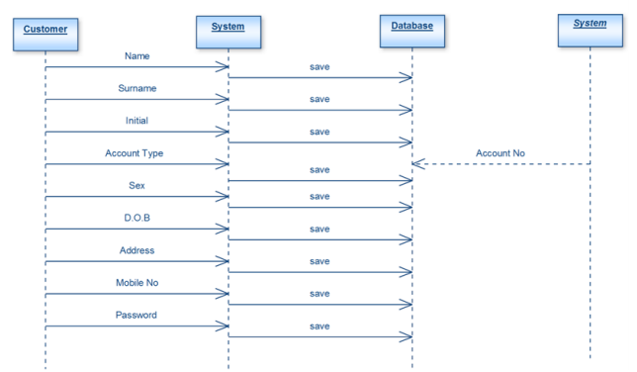

Fig: 4.1

This procedure collects all the personal information like name, date of birth, address, phone number, e-mail, verifying person, initial amount to be deposited from the user and provides unique identification number and account no. Using which user can make transaction after accepting only identification number and account number. It saves the information given by the user in our maintained database through file system support.

Once the registration is completed, the customers can login to make transactions on their accounts.

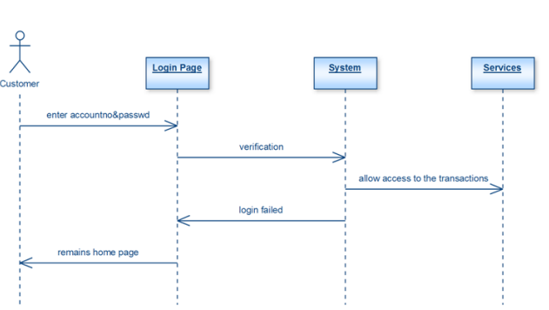

Fig: 4.2

The customer can withdraw, deposit and apply for loan EMI. Once the transaction is complete the customer can know his/her current account balance.

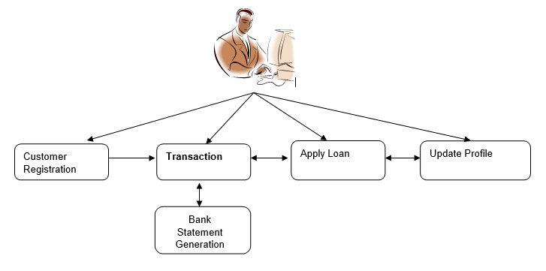

Fig: 4.3

**IMPLEMENTATION**

**5.1 Database Implementation**

Our choice of MySQL database is due to the fact that it can be used to set up a query which, when applied to a database typically returns a set of records that matches your SQL (Structured Query Language) query. It is also used to handle large databases

Several database tables and forms were designed and implemented in this project using MYSQL (Structured Query Language) database. Each of these tables and forms has their corresponding user interface that enables the user to supply data to the system. Application table was designed for this system in order to capture the account number of each application submitted. Once an application is entered, it is automatically numbered and this is seen on top of every application / Account registration form .The account number of every application is automatically captured and stored in the account database table. In the implementation phase, the project reaches fruition. A critical phase in SLDC (System Development Life Cycle) is the successful implementation of the system; implementation simply means bringing the new system into operation.

## 5.1.1 Entity-Relationship Model

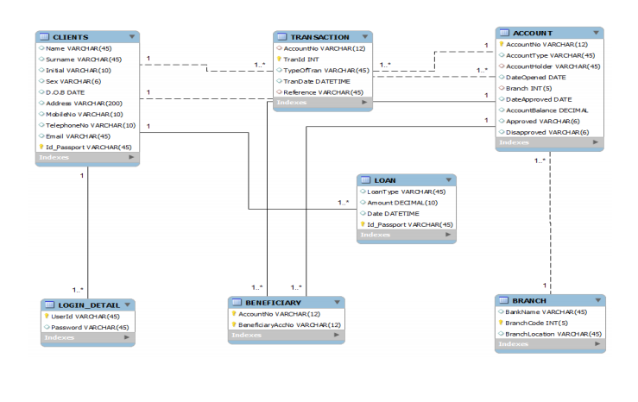

Fig: 5.1.1

## 5.2. System Object Model

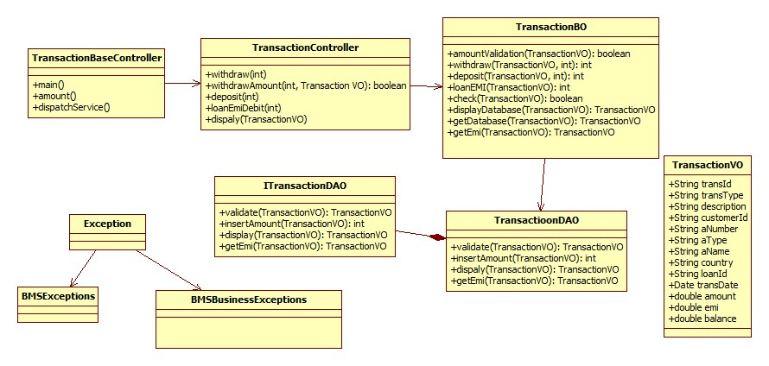

Fig: 5.2

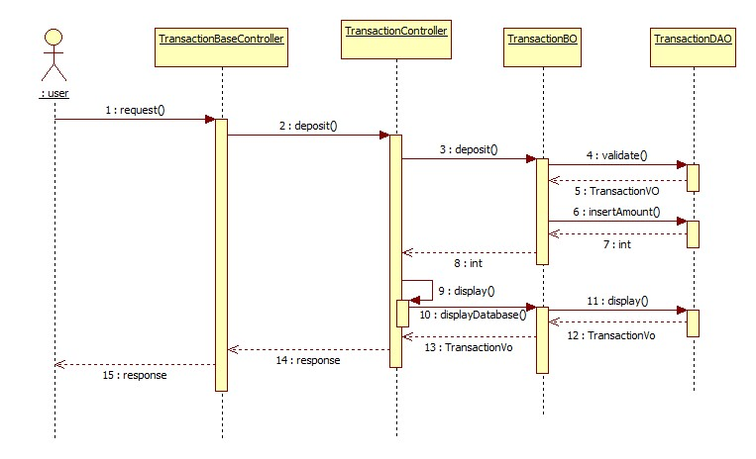

Fig: 5.3

## 5.3. Component Descriptions

|  |  |  |
| --- | --- | --- |
| **Class** | **Method** | **Program Logic** |
| TransactionBaseController | **renderTransactionMode()** | * Calls TransactionMode method to display the modes of transaction available-withdraw,deposit,loan EMI debit.. |
|  | **TransactionMode()** | * Displays the modes of transaction- EMI payment, transfer. * The customer enters the transaction mode. |
|  | **doTransaction ()**  **Parameters**  transactionType  **Return Type**  Service method of requested Trans Type | * This method calls different transaction in in the TransactionController with service as the parameter according to the selection made by the customer. |
| TransactionBO | **amountValidation**  **Parameters**  TransactionVO transactionVO  **Return Type**  boolean | * Checks whether enough fund is there in the account for the transaction to be done. |
| **ValidateAccNum()**  **Parameters**  TransactionVO transactionVO  **Return Type**  boolean | * Checks whether account number is there in the database. |
| **getDataBase()**  **Parameters**  TransactionVO transactionVO  **Return Type**  transactionVODB | * Calls validate method in the TransactionDAO with transactionVO as the parameter to get the database values. |
| **displayDatabase()**  **Parameters**  TransactionVO transactionVO  **Return Type**  transactionVODB | * Calls display method in the TransactionDAO with transactionVO as the parameter to get database values. |
|  | **ValidateCustomerDetail()**  **Parameters**  TransactionVO transactionVO  **Return Type**  transactionVODB | * Gets the customer details and account details from the database. |
|  | **displayConfirmation()**  **Parameters**  TransactionVO transactionVO  **Return Type**  transactionVODB | * Gets the transaction details from the database. |

Table: 5.3.1

## 5.4. User Interface Controls

|  |  |  |  |  |  |  |  |
| --- | --- | --- | --- | --- | --- | --- | --- |
| **Data Element** | **Control type** | **Default Values** | **Editable Field** | **Restrictions** | **Mandatory/**  **Non Mandatory** | **Data Type** | **Data**  **Size** |
| Name | Textbox | No | Yes | Only Alphabets | Mandatory | Varchar | 30 |
| Username | Textbox | No | Yes | Only Alphabets | Mandatory | Varchar | 30 |
| Password | Textbox | No | Yes | Only Alphanumeric and special char | Mandatory | Varchar | - |
| Re-type Password | Textbox | No | Yes | Only Alphanumeric special char | Mandatory | Varchar | 50 |
| Guardian Type | Combo box | No | Yes | Only Alphabets | Mandatory | Varchar | 30 |
| Guardian Name | Textbox | No | Yes | Only Alphabets | Mandatory | Varchar | 30 |
| Address | Textbox | No | Yes | Only Alphanumeric | Mandatory | Varchar |  |
| Citizenship | Combo box | No | No | Only Alphabets | Mandatory | Varchar |  |
| State | Combo box | No | No | Only Alphabets | Mandatory | Varchar |  |
| Country | Combo box | No | No | Only Alphabets | Mandatory | Varchar |  |
| Email Address | Textbox | No | Yes | Only Alphanumeric | Mandatory | Varchar | 50 |
| Gender | Combo box | No | No | Only Alphabets | Mandatory |  |  |
| Marital Status | Combo box | No | Yes | Only Alphabets | Mandatory | Varchar |  |
| Contact no | Textbox | No | Yes | Only Numeric | Mandatory | Num | 10 |
| Date of Birth | Textbox | No | Yes | Valid Date format | Mandatory | Date |  |
| Registration Date | Textbox | Yes | Yes | Valid Date format | Mandatory | Date |  |
| Account type | Combo box |  | Yes | Only Alphanumeric | Mandatory |  |  |
| Branch Name | Combo box | No | Yes | Only Alphabets | Mandatory | Varchar | 30 |
| Citizen status | Textbox | No | No |  |  |  |  |
| Initial Deposit Amount | Textbox | No | Yes | Only Numeric | Mandatory | Num | 10 |
| Identification Proof Type | Combo box | No | Yes |  | Mandatory |  |  |
| Identification Document No | Textbox | No | Yes | Only Alphanumeric | Mandatory | Varchar | 30 |
| Reference account holder name | Textbox | No | Yes | Only Alphabets | Mandatory | Varchar | 30 |
| Reference account holder acc. No | Textbox | No | Yes | Only Alphanumeric | Mandatory | Varchar | 30 |
| Reference account holder address | Textbox | No | Yes | Only Alphanumeric | Mandatory | Varchar | 50 |
| Alternate Address | Textbox | No | Yes | Only Alphanumeric | Mandatory | Varchar | 50 |
| Alternate Contact Number | Textbox | No | Yes | Only numeric | Mandatory | Varchar | 50 |

Table: 5.4.1

# SUMMARY

A summary of the achievements of this project, the existing system was analyzed, after which information were gathered followed by the analysis of those data. Based on the analysis, the limitations of the existing system were identified which initiated the choice of this project topic. This was followed by the system design, specification, database design, client side design, server side design, interface design and system security design. The implementation of these designed units was carried out successfully. After the design and implementation of the various units, system testing was carried out both on unit and general testing basis using test data to check the expected and actual test result. Finally, the performance evaluation of the system was certified since it is doing what it was designed to do.

# REFERENCES

# Fluaghter, R. (1990), Computerized Adaptive Testing, Hillsdale, New York: ACM press.

Glass, H. (2000), Interpretation of International Banking System, New Jersey: Vintage publication.

Klausmeier, J. (1984), Networking and Microcomputers Eric Digest NY, Clearing House on Information Resources, New York: Academic press.

Lewis, I. (2001), Computerization of Banking Systems, New York: Pearson Publication.

Molina, J.K. (1997), Item Banks Information Storage and Management.

Olea, J. & Prieto, G. (1999), Tests Information: Fundamental Application. Educational Research, Washington DC: DP Publication ltd.

Renom, J. (1997), Perspective Tests Adaptive Information, New York: Yarchi Press.

Sands, W. (1997), Computerized Adaptive Testing, American Psychological association, Washington DC: McGraw Hill.

Vossen, G. (1991), Data Models, Database Languages. And Database Management Systems Adison-Wesley Publishing, New Orleans: Pitman Publication.

Wise, S., & Kingsbury, G. (2000), Practical Issues in Developing and Maintaining a Computerized Adaptive Test: Fundamental Application, New York: ACM Press.

# APPENDIX A

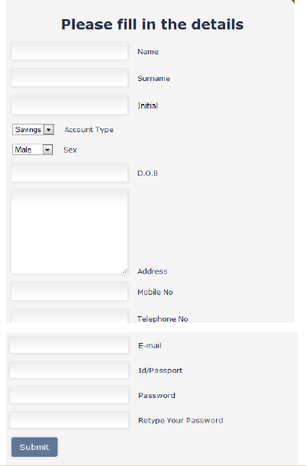

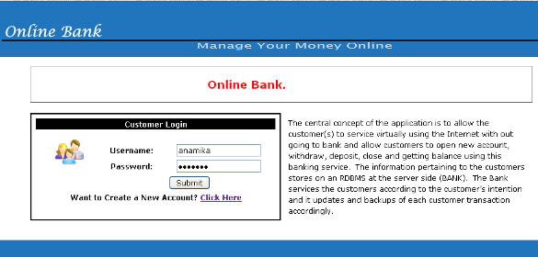



**Project Review Evaluation Sheet**

|  |  |
| --- | --- |
| **Components Distribution** | **Marks Awarded** |
| Problem definition, motivation and objective (3) |  |
| Literature Survey or related work (3) |  |
| Preliminary design and module description (3) |  |
| References (1) |  |
| **Total (Out of 10)** |  |

Karunakar Madiraju

Project Manager,

Senior Manager - Projects,

Cognizant Technology solutions.

**Signature of Internal Guide with Name Signature of External Guide**